Inventory Data Analysis and Insights
Introduction
This report proposes architecture that improves operational efficiency and supports strategic inventory planning. Using Microsoft Power BI (Microsoft, 2026), this report analyzes ABC Retailer’s inventory to address key issues like stockouts, excess inventory, and forecast inaccuracies. It identifies the main factors driving inefficiencies and proposes strategic optimization solutions to enhance operational efficiency, improve profitability, and ensure product availability.
1. Methodology
1.1 Data Processing
The dataset 3 (Saafein, 2026) includes key variables such as:
- Stockout rate
- Demand forecast accuracy
- Excess inventory holding costs
- Order processing time
- Customer order cancellation rate
Data was cleaned and transformed into Power BI (Microsoft, 2026) to ensure consistency and accuracy.
1.2 Analytical Techniques
The following techniques were applied:
- KPI Metrics
  - Average Stockout Rate: 18.56%
  - Forecast Accuracy: 40.98%
  - Excess Inventory Cost: 19.29%
- Correlation Analysis
  - Forecast Accuracy vs. Stockout: -0.89
  - Processing Time vs. Cancellation Rate: 0.75
- Visualizations Used
  - Heatmap table (product-level performance)
  - Bar chart (stockout rate by product)
  - Scatter plots (relationship analysis)
2. Data Analysis & Insights
2.1 Overall Inventory Performance
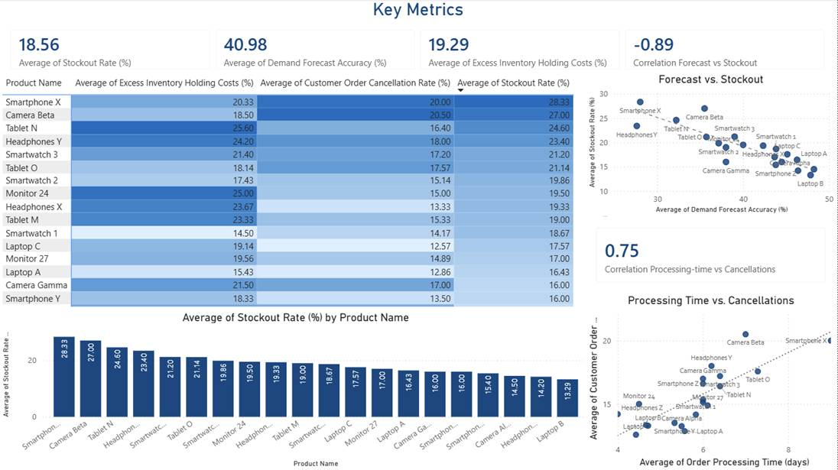
Insight through the key metrics:
- The average stockout rate (18.56%) is quite high, indicating frequent product unavailability leading to unmet demand from customers in several scenarios.
- Forecast accuracy is low (40.98%), indicating weak demand forecast accuracy.
- Excess inventory holding cost (19.29%) is also high, noticed inefficiency in stock control.
Interpretation:
ABC Retailer is facing 2 main circumstances:
- Understocking (stockouts)
- Overstocking (high holding costs)
This reflects imbalanced inventory planning from ABC Retailer Operations.
2.2 Forecast Accuracy vs. Stockouts
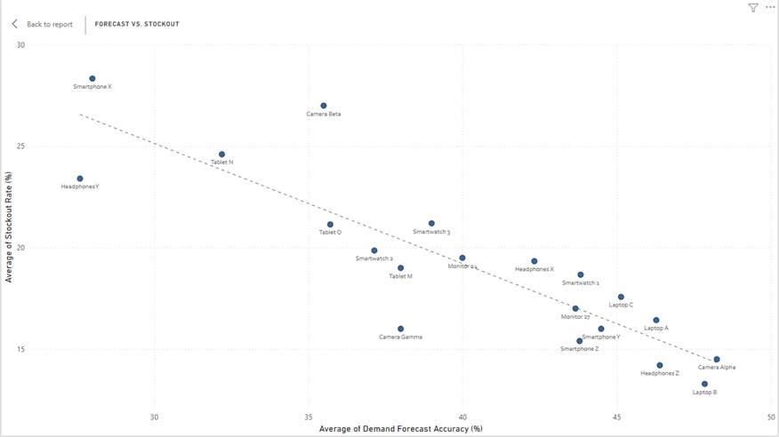
Insight:
- With a strong negative correlation (-0.89) between forecast accuracy and stockout rate.
- The higher forecast accuracy (for example: laptops) shows the lower stock-out rates.
- Products with low forecast accuracy (for example: smartphones, headphones) have essential higher stockouts.
Interpretation:
- Poor demand forecasting is the main reason for stockouts.
- Improving forecast accuracy will directly reduce stock shortages, and have more chances to enhance the sale rate
2.3 Processing Time vs. Order Cancellations
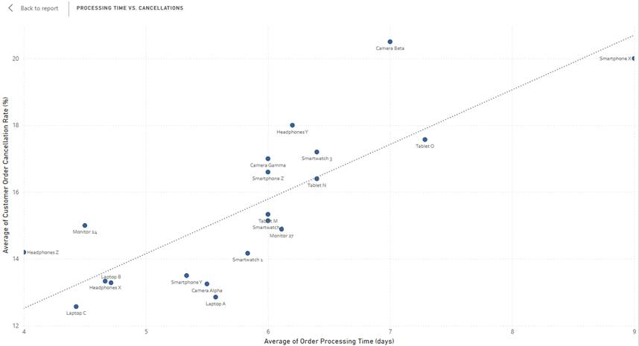
Insight:
- Strong positive correlation (0.75) between order processing time and cancellation rate.
- The longer processing times (for example: smartphones, cameras) experience, the more cancellations happen.
Interpretation:
- Latency in order fulfillment has a negative impact on customer satisfaction.
- The slower the processing time is, the more cancellations happen.
2.4 Product-Level Inventory Issues
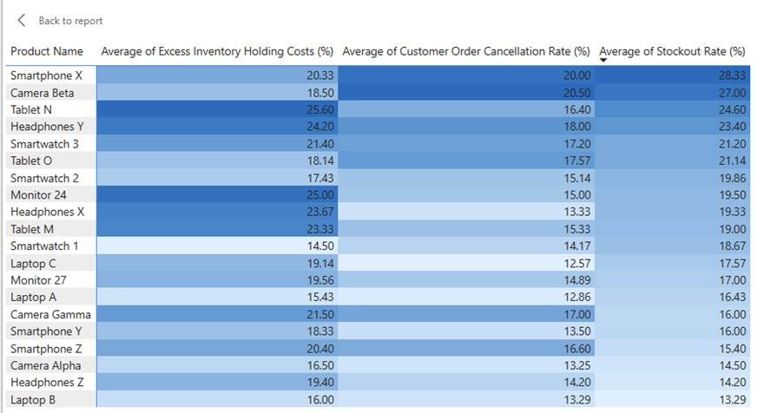
Insight:
- Some products (for example: Tablet O, Smartphone X, Camera Beta) show:
  - High stockout rates
  - High cancellation rates
- Others (e.g., Headphones Z, Monitor 24) show:
  - High excess inventory costs but lower demand
Interpretation:
- High-demand items are understocked
- Low-demand items are overstocked
- This addressed lack of demand-based inventory allocation.
2.5 Stockout Rate by Product
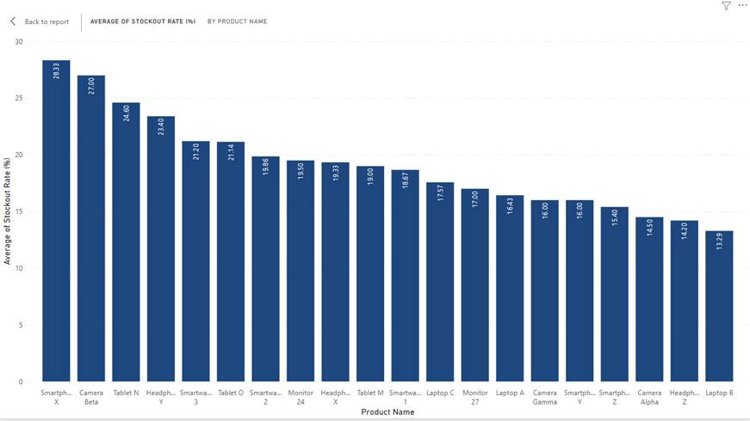
Insight:
- Highest stockout rates observed in:
  - Smartphone X (~28%)
  - Camera Beta (~27%)
  - Tablet N (~24%)
- Lowest stockout rates:
  - Laptop B (~13%)
  - Headphones Z (~14%)
Interpretation:
- Best-selling products are not restocked efficiently
- Slow-moving products are overstocked, which lead to poor use of the holding cost
3. Key Issues Identified
Based on the analysis:
- Low forecast accuracy (40.98%) driving stockouts
- Imbalance between supply and demand between best-selling and slow-moving products
- High excess inventory costs (19.29%) due to overstocking
- Inefficient order processing increasing cancellations
- Lack of prioritization for best-selling products
4. Strategic Recommendations
4.1 Reinforce and Improve Demand Forecasting
Recommendation:
Implement advanced forecasting models based on historical sales data and trends.
Justification:
- Strong negative correlation (-0.89) proves forecasting directly impacts stockouts
- Reinforcing the accuracy of demand forecast will minimize the excess inventory holding rate
4.2 Implement ABC Classification
Recommendation:
Classify products based on value and demand:
- A: High-demand (SmartphonesX, TabletsN, Camera Beta)
- B: Middle-demand (Tablet O, Smartwatch 2)
- C: Low-demand (Laptop B, Headphones Z)
Justification:
- Dashboard shows uneven demand distribution
- Enables better resource allocation
4.3 Optimize Reorder Opportunities
Recommendation:
Adjust reorder levels dynamically based on demand change and waiting time.
Justification:
- Longer in waiting time indicate, the higher cancelation effect directly to the low reorder chances
4.4 Reduce Overstock Inventory
Recommendation:
- Apply discounts or promotions for slow-moving products
- Group low-demand items
Justification:
- High excess inventory costs (19.29%)
- Identified overstocked items in heatmap
4.5 Reinforce Order Processing Efficiency
Recommendation:
- Automate order fulfillment processes
- Optimize warehouse operations
Justification:
- Strong positive correlation (0.75) shows delays increase cancellations
4.6 Real-Time Monitoring with Power BI
Recommendation:
Use dashboards for continuous tracking of KPIs.
Justification:
- Enable proactive decision-making
- Prevents recurring inventory issues
Conclusion
ABC Retailer faces two measurable problems: a planning failure driven by 40.98% forecast accuracy (r = -0.89 with stockout rate), and an execution failure where slow processing drives cancellations (r = 0.75). Both are visible across the Power BI analysis and result in the same outcome — capital tied up in the wrong products while the right ones run out of stock.
The recommendations in Part 3 address these directly: predictive forecasting closes the accuracy gap, ABC classification realigns inventory with actual demand, and real-time IoT monitoring reduces fulfillment delays. Importantly, these changes do not require spending more on inventory overall — the evidence suggests better allocation reduces total investment while improving availability (Epicor, 2024; Feizabadi, 2022). The dataset provides a clear starting point: prioritize Smartphone X, Camera Beta, and Tablet N for stockout intervention, and Headphones Z and Monitor 24 for overstock reduction.

References
Epicor. (2024). Three types of supply chain analytics: Descriptive, predictive, and prescriptive. https://www.epicor.com/en-us/blog/supply-chain-management/three-types-of-supply-chain-analytics/
Feizabadi, J. (2022). Machine learning demand forecasting and supply chain performance. International Journal of Logistics Research and Applications, 25(2), 119–142. https://doi.org/10.1080/13675567.2020.1803246
Microsoft. (2026). Power BI (Version January 2026) [Computer software]. https://powerbi.microsoft.com/
Saafein, O. (2026). I-Business Analytics–Issue3 dataset [Data set]. University of the Pacific.

